CREW/SPECTATOR INFORMATION

Support crews/Spectators are most welcome at the Scenic Rim Ultra Marathon. We love support crews – especially those that dress up and cheer loudly! The more people and the more enthusiastic you are the better the atmosphere for the runners. To keep the event manageable as well as fair and safe for all runners, and to make sure support crews do not get lost, there is some information support crews need to know.

Support crews are in for a real treat. This is a spectacular course and you will see some amazing parts of the Scenic Rim. Please bear in mind that there may be lots of support crew vehicles driving and parking on narrow roads. Please keep your speed down and lights on and be careful entering and existing parking areas. There is absolutely no need to speed to see your runner at the next aid station. You will have plenty of time.
Mobile phone coverage on the course is good.
Crews must wait to assist their runners until after the official check-in and medical evaluation (if required)
Crews must stay within 200m of the checkpoint while attending to their runners.
Crews must never park in such a way to block traffic, access to the trail, checkpoint or by double parking.
Crews are responsible for the removal of their rubbish – no littering.
Competitors will be held responsible for the actions of their crews.
Support Crews are not compulsory and runners can self-support at the event by making use of the drop bag service at checkpoints 3/7, 4/6, 5, 7, 8, 9 and the finish line. If you do choose to use a support crew, they only permitted to assist runners at the following checkpoints:

105km

Checkpoint Location |  | Distance from start | Distance from last  Aid Station | Cut-off time from last checkpoint | Spectators Allowed | Drop Bags | Pacers
Mt Joyce  Cp1 |  | 12.65 km | 12.65 km | 2.5hrs | Yes | No | No
Lillibrook  Cp 2 |  | 35.6 km | 22.95 km | 3.5hrs | Yes | Yes | No
The Café  Cp 3 (QMP) |  | 45.5 km | 10.6 km | 2.5hrs | Yes | Yes | No
The Dugandan Loop Of Doom  Cp 4 |  | 53.5 km | 8 km | 2.5hrs | Yes | Yes | Yes
Deliverance  Cp 5 |  | 62.8 km | 9.3 km | 2.5hrs | No | No | Yes
The Dugandan Loop Of Doom  Cp 6 |  | 79.1 km | 16.3 km | 4.0hrs | Yes | Yes | Yes
The Café Cp7  QMP |  | 87.1 km | 8 km | 2.5hrs | Yes | Yes | Yes
Mt Crumpet  Cp 8 |  | 97.8 km | 10.7 km | 3hrs | No | Yes | Yes
Mt Juberra  Cp 9 |  | 105.7 km | 8 km | 3.5hrs | No | No | Yes
The Finish  The Overflow Estate 1895 |  | 109.7 km | 4.7 km | 1.5hrs | Yes | Yes | Yes

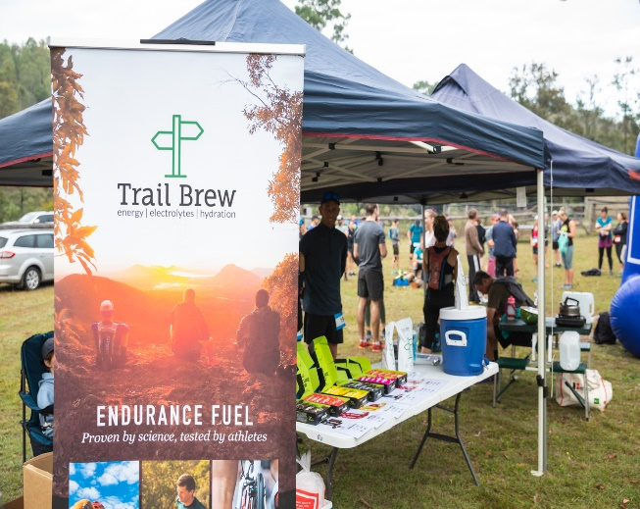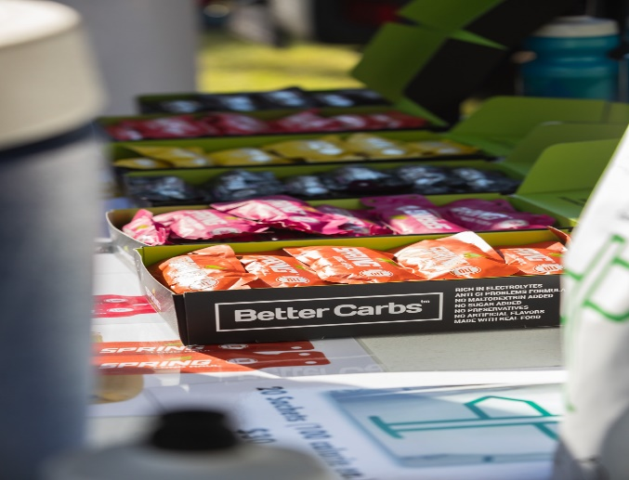

65km

Checkpoint Location | Distance from  start | Distance from last  Aid  Station | Cut-off time from last checkpoint | Spectators Allowed | Drop Bags | Pacers
Mt Joyce  CP 1 | 12.65 km | 12.65 km | 2.5Hrs | Yes | No | No
Lilybrook  CP 2 | 35.6 km | 22.95 km | 3.5Hrs | Yes | Yes | No
The Cafe (QMP) CP 3 | 45.5 km | 10.6 km | 2.5Hrs | Yes | Yes | Yes
The Crumpet CP4 | 56.8 km | 10.7 km | 3Hrs | No | Yes | Yes
Juberra  CP 5 | 64.8 km | 8 km | 3.5Hrs | No | No | Yes
Finish The Overflow  Estate 1895 | 69.5 km | 4.7 km | 1.5Hrs | Yes | Yes | Yes

Checkpoints locations for spectators and crew. These are the only checkpoints spectators and support crew can access. Please park in the allocated areas shown on each of the maps, which will be identified by witches hats.

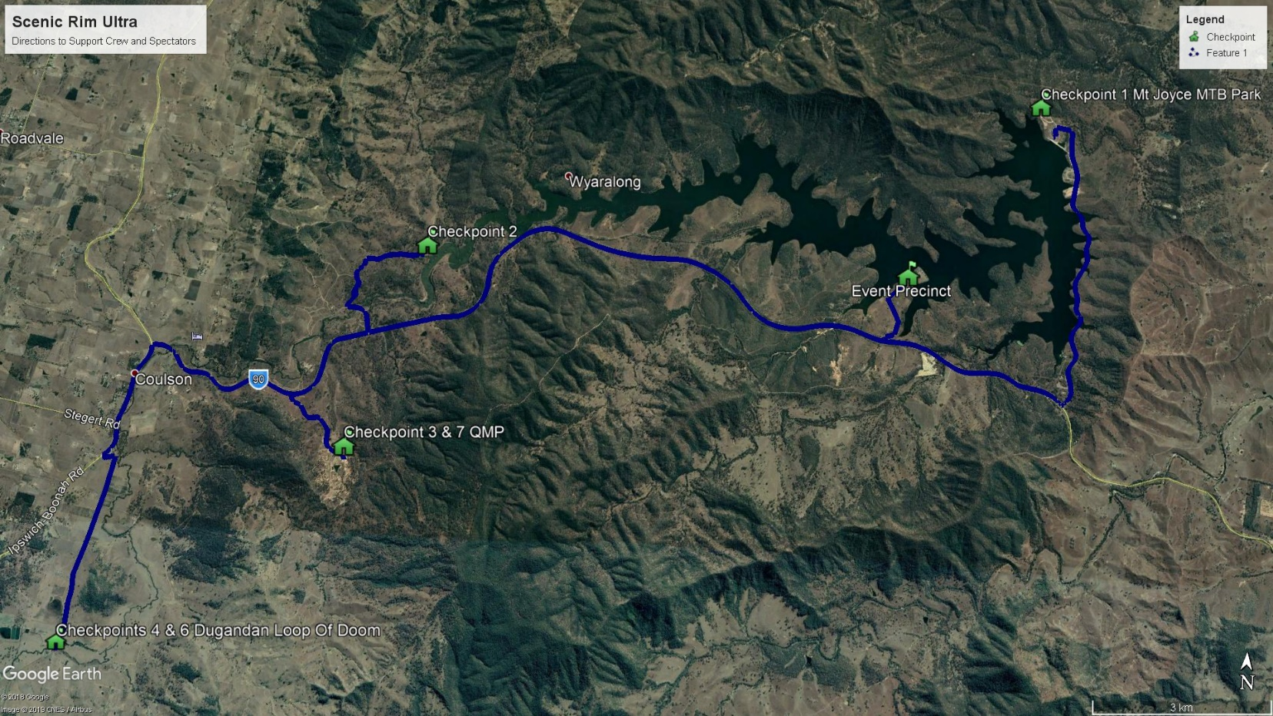

Start/Finish Line precinct. – The Overflow Estate 1895 Winery
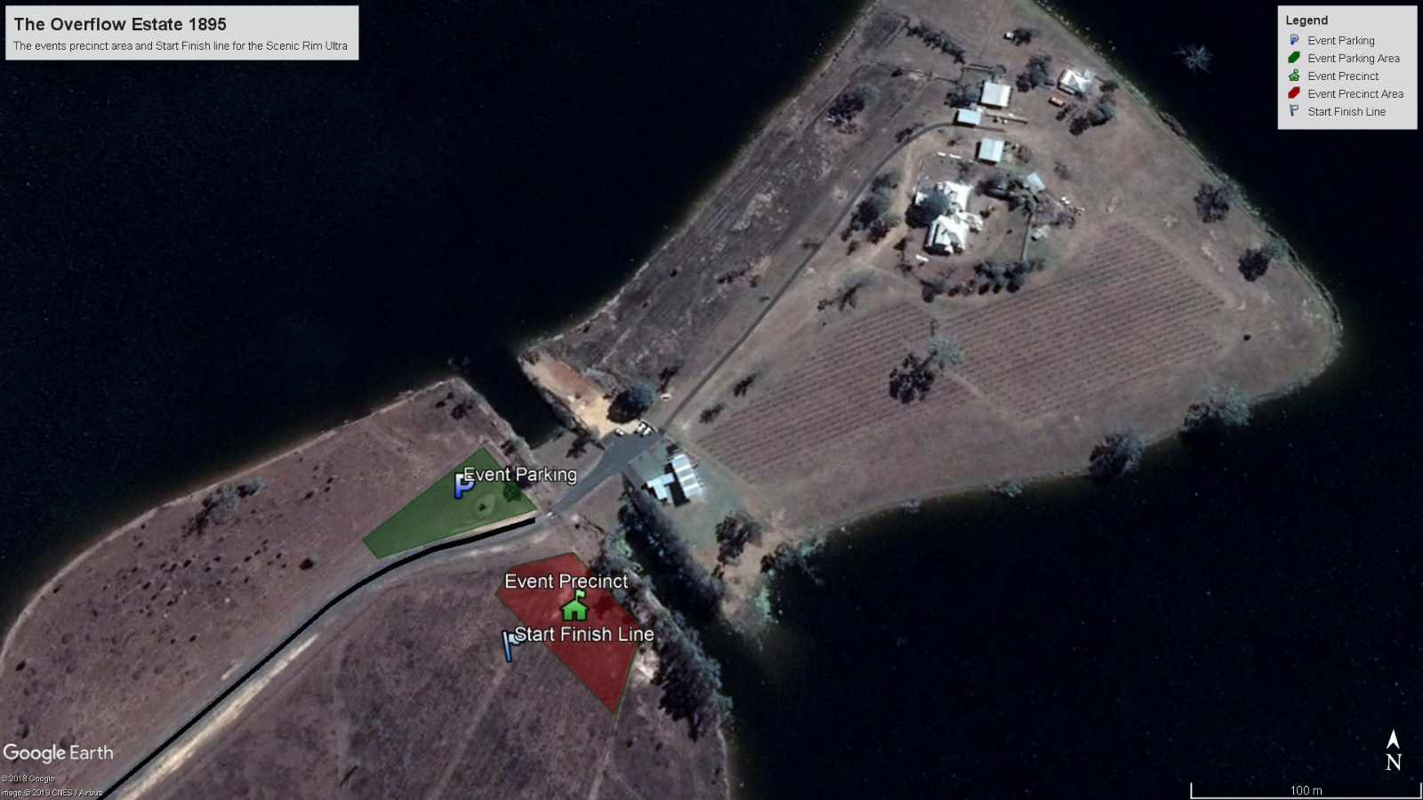
Checkpoint 1

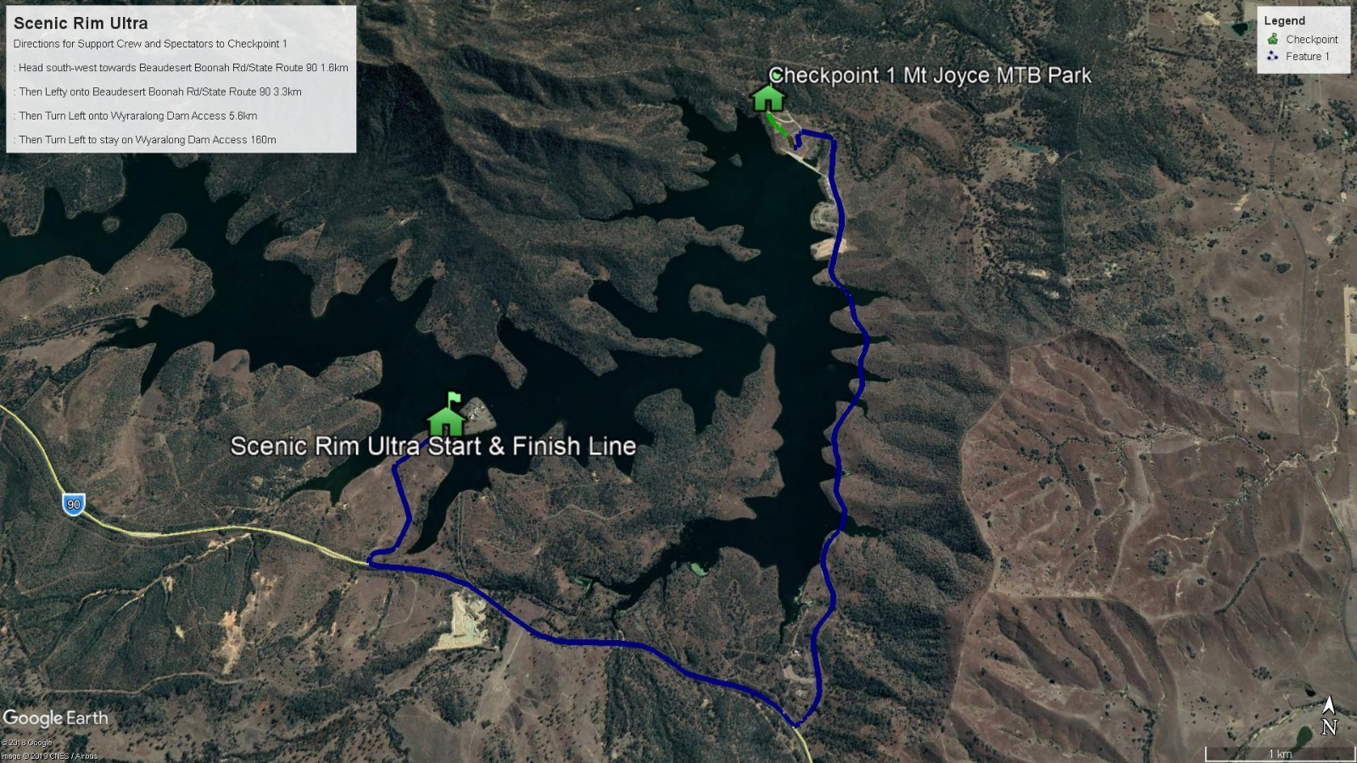

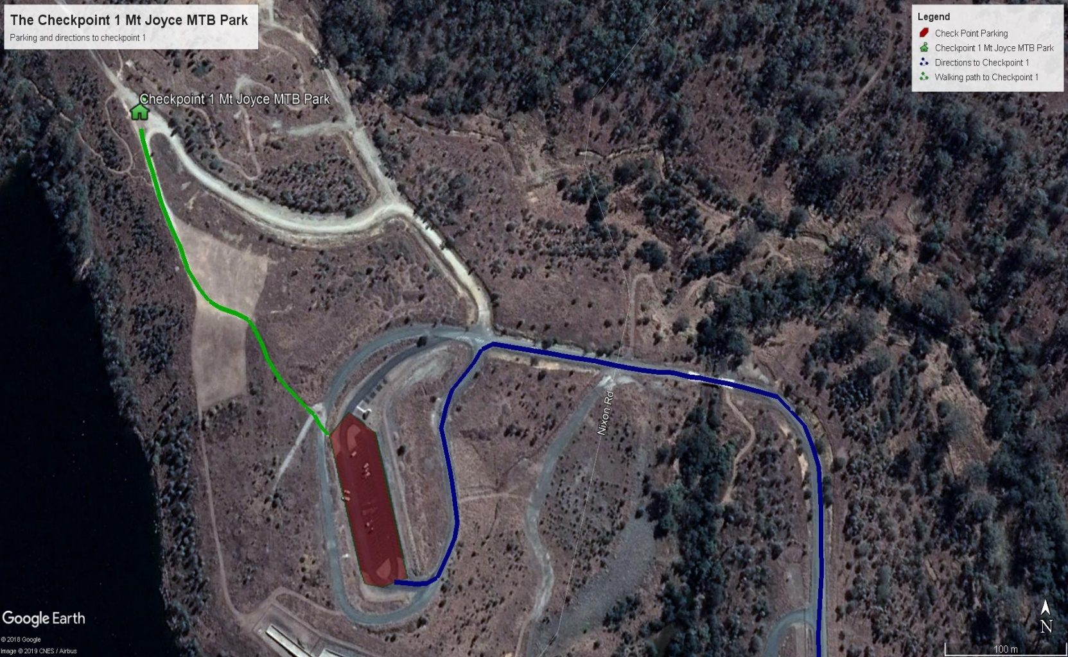
Checkpoint 2

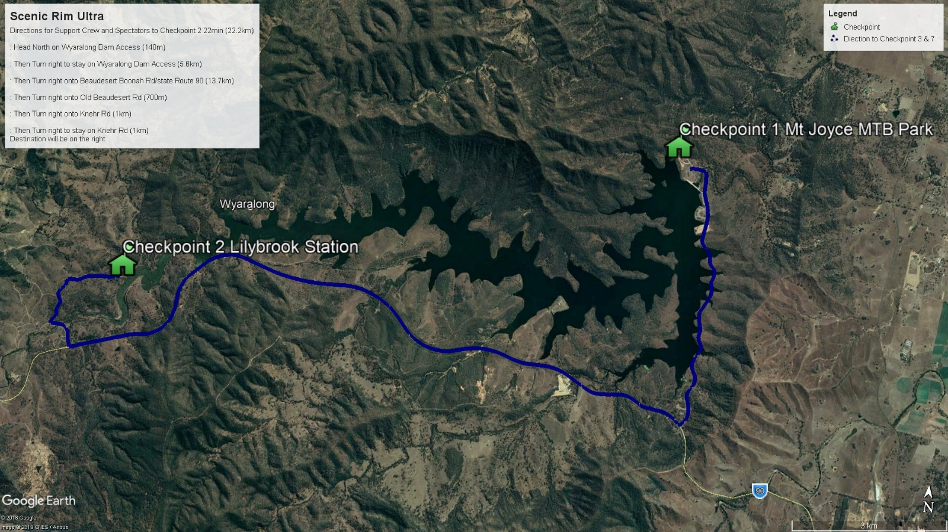

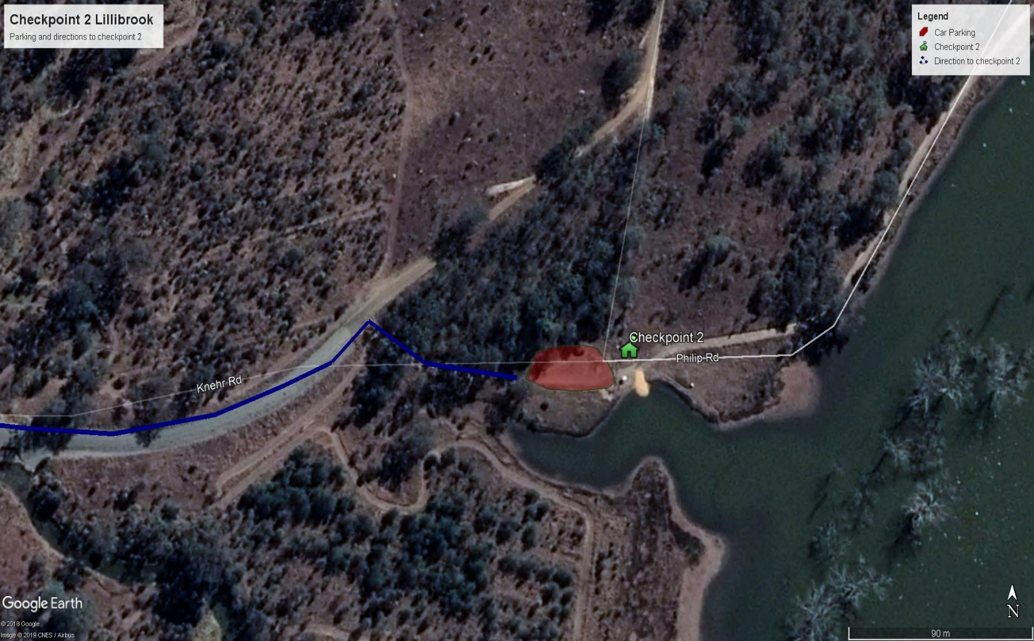
Checkpoint 3 and 7

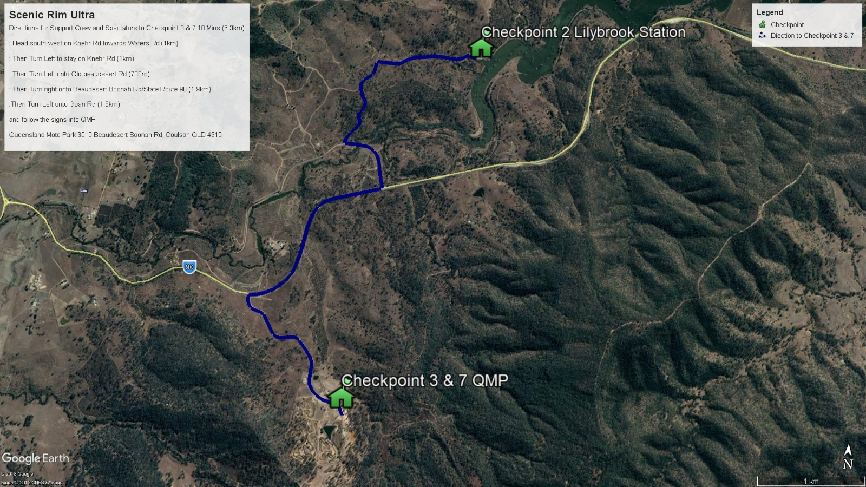

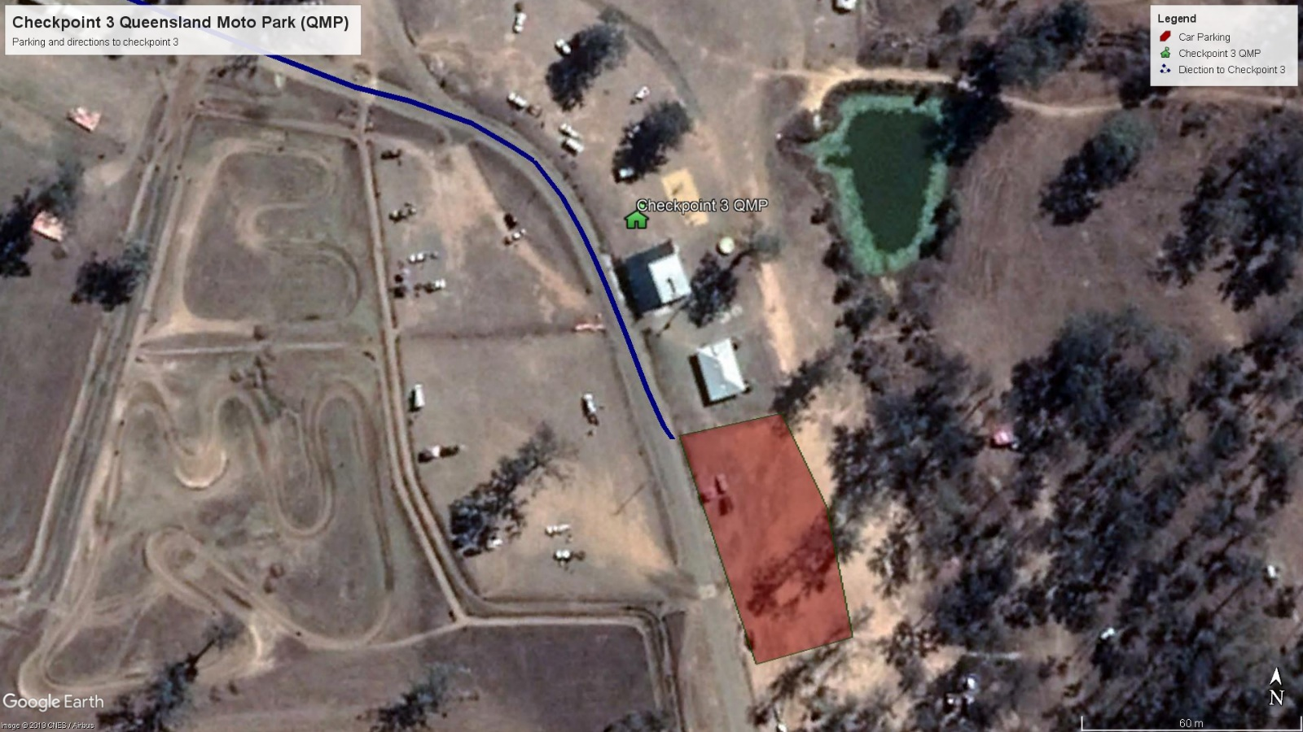
Checkpoint 4 and 6

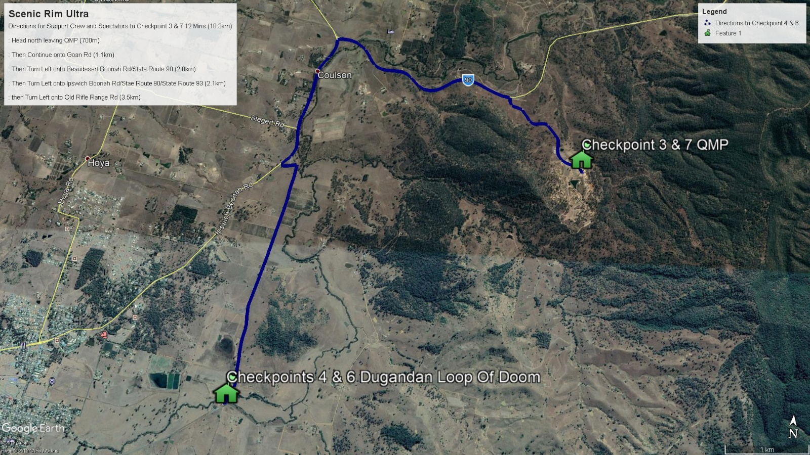

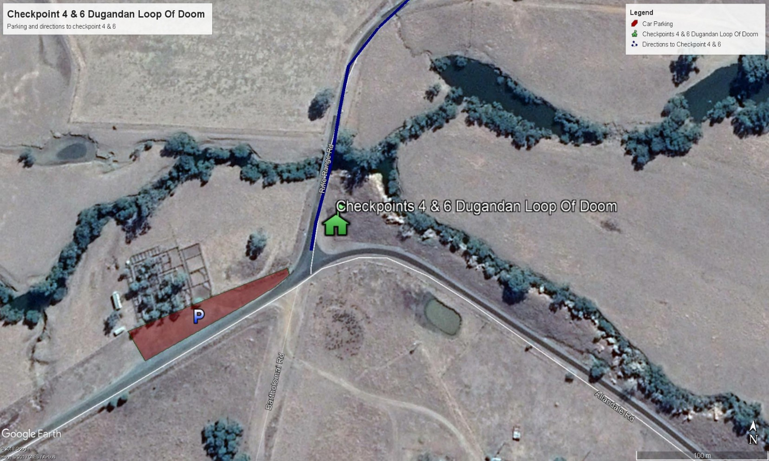
If you have any issues, please see the crew at the checkpoints.
We hope you have fun supporting your competitor out on the course and enjoy the views.

